What is Upper GI
Endoscopy?

Your doctor has determined that it is advisable to visually examine the lining of your esophagus, stomach and duodenum. Together these make up the “upper GI tract” as shown in the illustration.

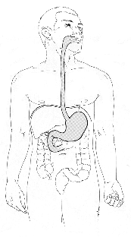

Many problems can affect the upper digestive tract and some cannot be readily diagnosed without direct inspection by endoscopy. Endoscopy refers to a direct view from within, using a long flexible tube about the thickness of the index finger.
If abnormalities are encountered, the doctor can pass other instruments through the endoscope without causing discomfort and obtain brushing (for cytology or a “pap” test) or biopsies. Since the lining of the digestive tract is not sensitive to scratching or pinching, you should not feel the biopsies.

Preparation for the test

Do not eat or drink anything after midnight the night before the examination. (Advise your doctor or nurse if you are a diabetic requiring insulin).
You may take necessary tablets or capsules by mouth using a small amount of water up to six hours before the examination.
Your stomach must be completely empty for the procedure and you may be requested to modify your dietary intake for the day prior to examination.
Someone needs to bring you to the endoscopy unit where the procedure will be performed. They will need to pick you up from the designated recovery area.
You will be asked to sign a consent for the procedure and you are encouraged to ask any questions you may have.

During the test

In order to relax you, a sedative will be given intramuscularly and/or intravenous. The medicine will make you feel sleepy and light-headed.
Your doctor will spray your throat with a topical anesthetic to numb the area and keep you from gagging.
The endoscope will be passed into your throat and guided into the upper digestive tract as you swallow. Remember that the tube will not interfere nor stop your breathing.
The light in the room will be dimmed to allow examiners to see better.

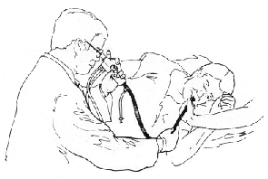
Air will be passed through the scope to distend your upper digestive tract. This may cause some discomfort or a full sensation until the air is withdrawn.
If necessary, biopsies or pap smears may be taken as described above.

After the test

You will be kept in the recovery room until most of the effects of the medications have worn off. You will remain on the stretcher at least an hour after the test. You will need to be awake and steady before you go home or are returned to your hospital room.
Do not eat or drink anything until you are alert and the effects of the anesthetic spray are gone. Thereafter, you may resume your usual diet unless otherwise instructed. Your throat may be a little sore for a few hours and you may feel somewhat bloated right after the procedure.
Should you have any undue discomfort, fever, persistent cough, bleeding or other difficulties, notify Dr. Ertan’ office at 713-794-0001.

NOTES

Upper GI

Endoscopy

Atilla Ertan, MD, MACG, FACP
6560 Fannin, #2208
Houston, TX 77030
713-794-0001

