PUD affects at least 10% of the population at some stage during their lifetime; approximately 15 million American adults have an active PUD at some time.

What is PUD?

Peptic Ulcer is a break of the tissue lining which may occur in one of several parts of the digestive tract: the swallowing tube (esophagus), the stomach, the upper small bowel (duodenum), or more rarely, another part of the small bowel. Duodenal ulcer is more common than gastric ulcer and affects mainly young to middle aged people.

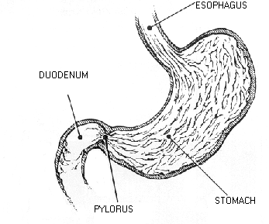

What causes PUD?

Helicobacter Pylori or the use of arthritis pain medicines, nonsteroidal anti-inflammatory drugs (NSAIDs) such as aspirin and others cause more than 98% of PUD. Identification of the ulcer cause is important for the cure of the disease.

How are PUDs diagnosed?

The symptoms of PUD may be vague or even nonexistent, especially due to NSAIDs. More common is epigastric distress, pain that causes awakening after midnight and occurs 1-3 hours after meals. Pain typically occurs in clusters or episodes lasting several weeks or months and is relieved by food or antacids. Patients with PUD may present with bleeding and perforation. The diagnosis of PUD depends on stomach x-rays or endoscopic studies. In diagnosing the stomach ulcers, the major concern is to distinguish between non-cancerous (peptic) and cancerous ulcers, which is possible by endoscopic exam, and biopsy. Helicobacter pylori can be diagnosed by endoscopic biopsies, blood tests and sometimes breath tests.

How are PUDs treated?

- Eat three well-balanced meals a day.
- Avoid substances that aggravate the symptoms such as alcohol, smoking, and beverages containing caffeine.
- Do not take aspirin and arthritis drugs (even most of them are over-the-counter).
- Selected antibiotics and acid reducing medications can cure PUD; it results in accelerated ulcer healing as well as prevention of ulcer relapse and ulcer complications.
- Most ulcers caused by arthritis drugs can be treated with selected medications.

If your ulcer does not respond to medical treatment or if you have further questions, please call 713-793-1530 or 713-794-0001.

NOTES

Peptic Ulcer
Disease

Atilla Ertan, MD, FACG, FACP
6560 Fannin, #2208
Houston, TX 77030
713-794-0001

