Digestion of food begins in the mouth and moves through the esophagus, stomach, and the small and large intestine. In the mouth, stomach, and the small intestine, food is mixed with digestive juices. The digestive juices break the food down into smaller chemical pieces or nutrients. These nutrients move along the small intestine, which is made up of three parts: the duodenum, jejunum, and ileum. The nutrients are absorbed into the bloodstream through the small intestine and carried to all parts of the body. Nutrients are needed for the body tog row and remain healthy.

The water and solid waste that remain after the nutrients are absorbed move into the large intestine. Most of the remaining water is absorbed into the bloodstream from the colon. The solid waste is passed out of the body as a bowel movement (BM) through the anus.

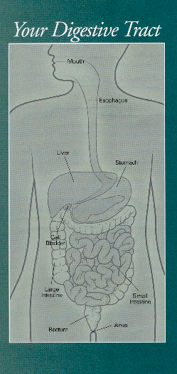

NOTES

Your Digestive
Tract

Atilla Ertan, MD, FACG, FACP
6560 Fannin, Ste. 2208
Houston, TX 77030
713-794-0001

